

Using JavaScript Function (onclick ())

I created a small project where I took an array that has an object in it and that object contains all the data in the table.

The main thing is that I have created a search bar, if you search there you can find all the data in the table.

This project I have used Onclick Function and Loop, Array, Object, if-else

\*Watch the Data Search Table

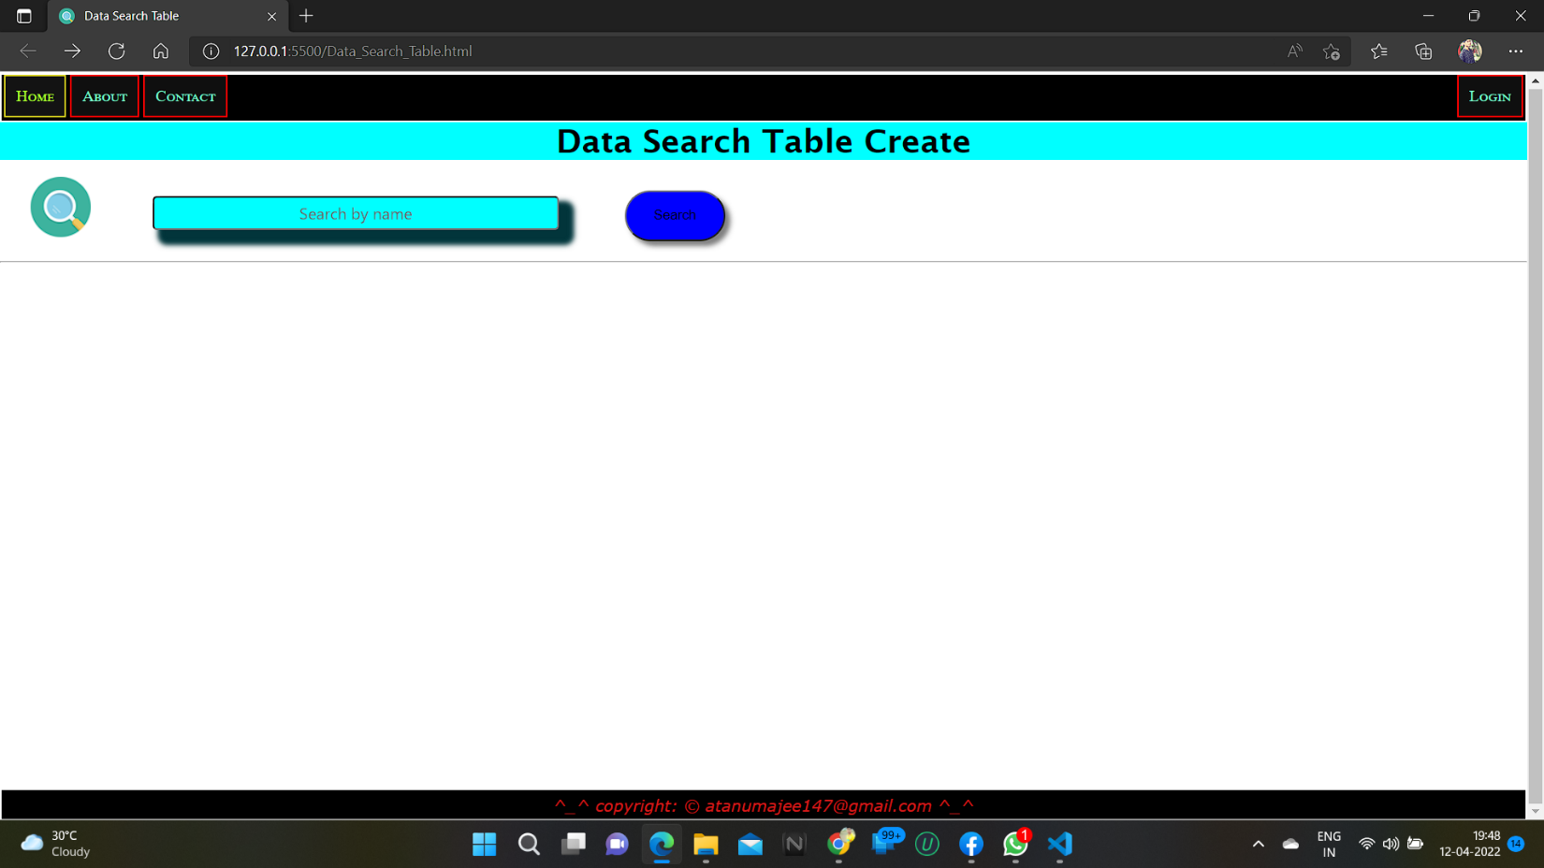

\*Click to the Search Bar or Search Icon than .

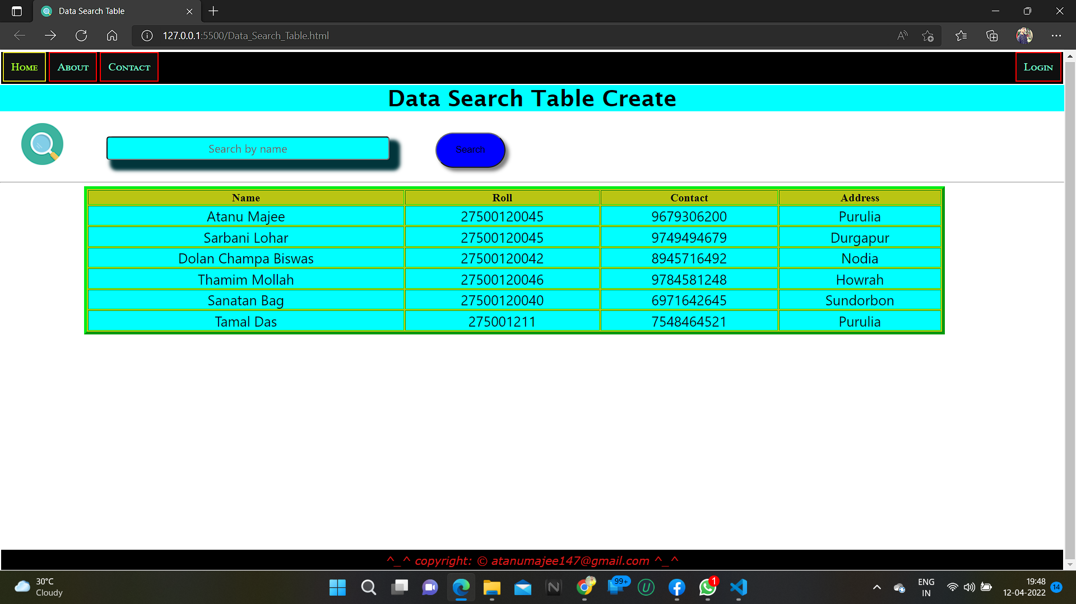

\*Type a name and Hit the Button:

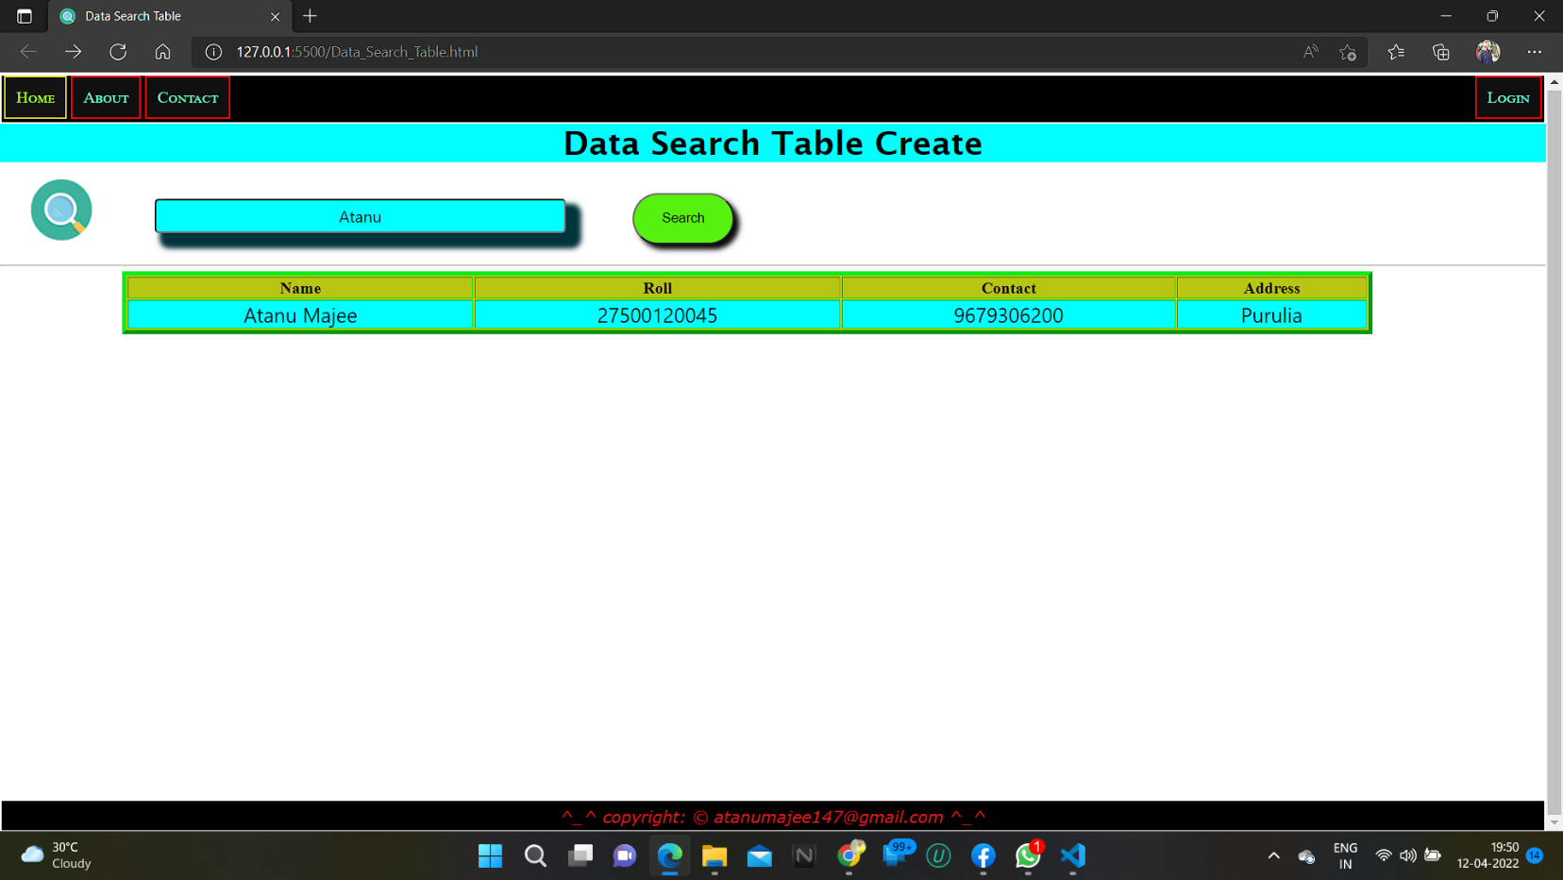

This project just for practice HTML, CSS and JavaScript languages

Editor: vs code

Thanks for Watching this Project:

*Created by Atanu Majee*

Link: <https://github.com/atanumajee147/>